

V 1.2
June 2026
XStep Design Specification
SMPL: FIO or Investigational Samples

Table of Contents
1 Purpose 3
2 Overview 3
3 Reasons for developing 4
4 Authorization 4
5 Assumptions/ Dependencies 4
6 Validation Checks 5
7 XStep Layout Design 5
8 Function Module(s) 6
9 Pseudocode 8
10 Test Scenarios 12
11 Revision History 13

Purpose
This document outlines the design, along with the configuration specifications for the XStep “SMPL: FIO/ Investigational Samples”.

Overview
The SMPL: FIO/ Investigational Samples XStep facilitates the process of taking representative samples after the solution has been transferred. The XStep guides the operator through the necessary steps for recording the storage location of the sample. By standardizing the FIO/ Investigational Samples process within the Electronic Batch Record (EBR), this step supports GMP compliance, enhances data integrity, and ensures that all required samples are taken and documented accurately for quality control, investigation, and release purposes.
The XStep contains two main input parameters:
- IV_HEADER - This can be changed in SiMPL MBR to display specific header text for the XStep
- IV_INSTR - This can be changed in SiMPL MBR to display a specific set of instructions for the XStep that will be displayed below the header
- IV_SAVOL: This can be changed in SiMPL MBR to display a specific description of the parameter to be recorded
- IV_STORT: This can be changed in SiMPL MBR to display a specific description of the parameter to be recorded
- IV_TEST: This can be changed in SiMPL MBR to display a specific description of the parameter to be recorded
- IV_TUTY: This can be changed in SiMPL MBR to display a specific description of the parameter to be recorded
- IV_SIGN – This can be changed in SiMPL MBR to author standalone signatures as part of the xstep.

The operator executes the “Get Equipment” button:
- Get Equipment - Function Button
The button is linked to the function module ZSMPL_FM_GET_ASSIGNED_EQUI_EBR. This module validates the equipment ID against Equipment Master data and performs the following operations:
- “Equip ID” - Input
- “Equip Description” - Output

The following information is pre-populated in the Sampling table:
- “Test” - Output
- “Sample Volume” - Output
- “Tube Type” - Output
- “Storage Temperature” - Output
The operator selects from the “Sample Pulled” dropdown if a sample has been pulled for this specific process:
- Sample Pulled - Input Dropdown
The operator enters the Physical Storage Location:
- “Physical Storage Location” - Input
Finally, the user who performed the sample step, records their signature in the “Performed By” field.
Functional Design
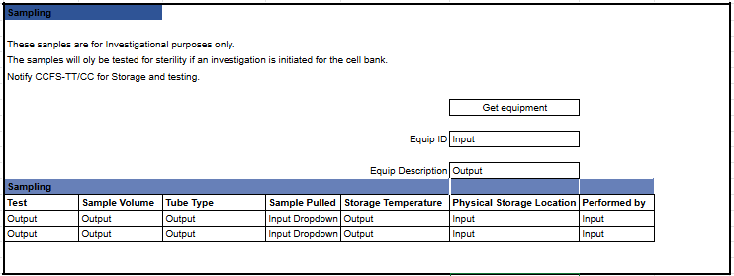

Reasons for developing
The primary goals of the SMPL: FIO/ Investigational Samples XStep is to ensure accurate, traceable, and compliant collection of samples for in-process control (IPC), quality control (QC), and release testing. It supports product quality assurance by enabling timely detection of deviations or contamination. Additionally, the XStep improves data integrity by automatically recording FIO/ Investigational Samples events in the EBR, reducing reliance on paper logs and minimizing transcription errors. It also enhances batch record completeness, standardizes FIO/ Investigational Samples practices, and provides full traceability of sampled materials within the batch lifecycle.

Authorization
N/A

Assumptions/ Dependencies
 | Assumption
1 | User signing signature fields is an approved user in the system with the correct access configuration

Validation Checks
Error Handling
Error | Action
Fields not pre-populated by default | Check MBR Configuration
Equipment not found | Check master data

XStep Layout Design
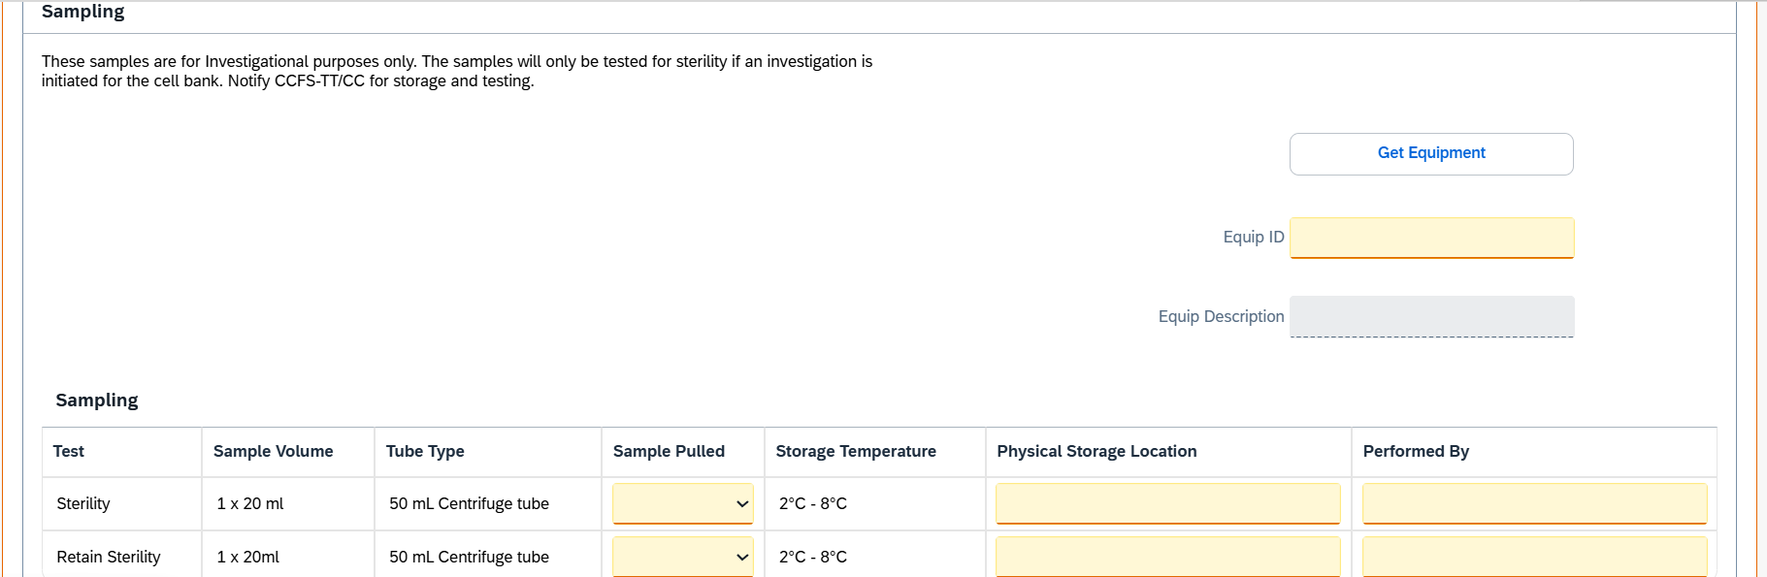

Function Module(s)
Function: /SMPL/PPPI_FM_SIG_ADD_DB_CB
Import Parameters:
Parameter Name | Associated Type | Short Text
IM_CONTROL_RECIPE | POC_DOCID | Control Recipe Number
IM_PHASE | VORNR | Activity Number
IM_STEP_IDX | INT4 | XStep Step Index Number
IM_STEP | CHAR30 | XStep Header
IM_SIGTYPE | CHAR20 | Signature Type
IM_USERID | XUBNAME | User Name
IM_DB_UP_DOWN | CHAR1 | Done By Up/Down
IM_VALIDATION_REQ | CHAR3 | Validation Required
IM_STEP_UUID | ZSMPL_DE_SMPL_SOG_UUID | XStep SOG UUID

Function: /SMPL/PPPI_FM_INITIAL_ACTIVE
Import Parameters:
Parameter Name | Associated Type | Short Text
IV_ACTIVE | CHAR1 | N/A
Export Parameters:
Parameter Name | Associated Type | Short Text
EV_ACTIVE | CHAR1 | N/A

Function: /SMPL/MBR_DEP_CHECK_ACTIVE
Import Parameters:
Parameter Name | Associated Type | Short Text
IM_CONTROL_RECIPE | POC_DOCID | N/A
IM_PHASE | VORNR
IM_AUFNR | AUFNR
IM_STEP_UUID | /SMPL/MBR_SOG_UUID
IM_PLANT | WERKS_D

Export Parameters:
Parameter Name | Associated Type | Short Text
EV_ACTIVE | CHAR1 | N/A

Exceptions:
Exception | Short Text
CONTROL_RECIPE_INITIAL

Pseudocode
Function: /SMPL/PPPI_FM_SIG_ADD_DB_CB
- Signature Type Identification
- Assign the incoming signature type (IM_SIGTYPE) to local variable lv_sigtype.
- A CASE structure is used to determine behavior based on the type:
  - ' ' (Done By)
  - 'C' (Checked By)
  - 'O' (Validation Flag Only)
- Done by Signature(lv_sigtype = '')
a. Optional Step Name Update
- If IM_STEP is provided, update the XStep header in table /SMPL/PPPI_PISST.
b. Determine Position for Signature Insertion
- If IM_DB_UP_DOWN is empty:
  - Insert the new signature above the current item by fetching MIN(UNIQUE_SEQID) and inserting one row before it.
- If IM_DB_UP_DOWN = 'B':
  - Insert the new signature below the current item by fetching MAX(UNIQUE_SEQID) and inserting one row after it.
- In both cases:
  - Use IM_USERID as the signer (SIGN_ID)
  - Signature type description from TEXT-001
  - Insert new row into /SMPL/PPPI_PISST
- Checked By Signature (lv_sigtype = 'C')
a. Get Signature Start Point
  - Select the UNIQUE_SEQID of the "Checked By" step matching the given input.
b. Determine Signature End Point
- Fetch all prior 'C' type signatures for the same control recipe (and optionally across all phases).
- Determine the highest UNIQUE_SEQID lower than the start point to use as the end.
c. Update Checked By Step
- Set the SIGN_ID and mark the step as COMPLETED = 'X'.
d. Complete All Steps Between Start and End
- Fetch and loop over all steps with UNIQUE_SEQID between the start and end boundaries.
- Mark each row in that range as COMPLETED = 'X'.
- Update the database using MODIFY.
- Validation Flag Update (lv_sigtype = 'O')
a. Determine Validation Value
  - If IM_VALIDATION_REQ = '2', set to 'No', else 'Yes'.
b. Update Validation Requirement
- Update the VALIDATION_REQUIRED field for the current control recipe, phase, and step index in /SMPL/PPPI_PISST.
Additional Notes:
- Purpose:
Dynamically inserts or updates signature records in /SMPL/PPPI_PISST depending on the role of the signer (Done By, Checked By, or Validator).
- Features:
Supports step name overrides and UUID tracking.
Allows insertion before or after specific records using IM_DB_UP_DOWN.
Ensures Checked By signatures cascade completion to preceding steps.
Accommodates flexible validation logic.
- Error Handling:
No explicit RAISE statements or exception handling.
Relies on CHECK and SY-SUBRC evaluations to exit silently if lookup conditions fail.
- Extensibility:
Designed with optional parameters (IM_STEP, IM_SIGTYPE, IM_DB_UP_DOWN, IM_VALIDATION_REQ) to support various signing scenarios.

Function: /SMPL/PPPI_FM_INITIAL_ACTIVE
1. Initialization
a. Input parameter IV_ACTIVE is optionally provided by the calling logic.
b. Constants gc_yes, gc_no, and gc_inside_range are assumed to be defined globally in the context of the function module.
2. Active Flag Evaluation
a. The function checks if the input value IV_ACTIVE falls within the expected valid range, represented by gc_inside_range.
b. Based on the result:
- If the input value is not equal to gc_inside_range, the XStep is marked as inactive by setting EV_ACTIVE = gc_no.
- If the input value is equal to gc_inside_range, the XStep is marked as active by setting EV_ACTIVE = gc_yes.
3. Output Assignment
a. The evaluated result is returned in the EV_ACTIVE export parameter for use by the calling logic (e.g., XStep configuration, PI sheet rendering).
Additional Notes
- This is a simple normalization function that abstracts how activation flags are interpreted for PPPI XSteps
- The use of constants (gc_yes, gc_no, and gc_inside_range) allows the logic to be aligned with broader application settings or standards.
- Helpful in scenarios where input values may vary but need to result in consistent "active" or "inactive" behavior.
- Input is optional, so defaulting behavior can be configured outside this function.
- This function improves clarity and consistency in determining whether an XStep should be active when rendered in the PI Sheet.

Function: /SMPL/MBR_DEP_CHECK_ACTIVE
1. Initialization
a. Input parameters provide context for determining whether an MBR (Manufacturing Batch Record) step can be activated:
- IM_CONTROL_RECIPE (POC_DOCID) – Control recipe ID identifying the batch instruction.
- IM_PHASE (VORNR) (Optional) – Operation or phase within the process order.
- IM_AUFNR (AUFNR) (Optional) – Process order number associated with the step.
- IM_STEP_UUID (/SMPL/MBR_SOG_UUID) – Unique step identifier (SOG).
- IM_PLANT (WERKS_D) – Plant code for process context.
b. The function first validates that IM_CONTROL_RECIPE is not initial.
- If it is initial, the exception CONTROL_RECIPE_INITIAL is raised.
c. Internal data is initialized:
- lt_ord_sigs: Internal table for storing order signature data from /SMPL/MBR_OR_SIG.
- ls_step_dep: Work area for step dependency data.
- Routine LOAD_INTERNAL_DATA is called to populate internal buffers (g_ord_data-t_ord_deps) using IM_AUFNR, IM_CONTROL_RECIPE, and IM_STEP_UUID.
2. Signature Data Retrieval
a. The function retrieves signature records for the process order from database table /SMPL/MBR_OR_SIG.
b. Selected fields include: AUFNR, SOG_UUID, TYPE, CREATED_DATE, CREATED_TIME, DEST_NAME, SIGN_ID, SIGN_DATE, and SIGN_TIME.
c. Only signatures related to the specified order (AUFNR = IM_AUFNR) are selected.
d. These records are stored in the internal table lt_ord_sigs for later evaluation.
3. Dependency Evaluation
a. The function loops through dependencies in g_ord_data-t_ord_deps where:
- TARGET_UUID = IM_STEP_UUID, and
- DEP_RULE is either gc_perform_before_start_rule or gc_verify_before_start_rule.
b. For each dependency record:
- If the rule is PERFORM BEFORE START, it checks whether the prerequisite step (PREREQ_UUID) has a pending perform signature (gc_perform_signature) with SIGN_ID = abap_false.
- If the rule is VERIFY BEFORE START, it checks whether the prerequisite step (PREREQ_UUID) has a pending verify signature (gc_verify_signature) with SIGN_ID = abap_false.
c. If an incomplete signature is found, the step is marked inactive (EV_ACTIVE = gc_step_inactive).
d. If all prerequisite signatures are complete, the step is marked active (EV_ACTIVE = gc_step_active).
4. Output Assignment
a. The evaluated activation status is returned in the export parameter EV_ACTIVE.
- gc_step_active – All prerequisite steps are completed; the current step can start.
- gc_step_inactive – At least one prerequisite step is incomplete; the current step remains blocked.
Additional Notes
This function determines whether a dependent step in a Manufacturing Batch Record is eligible to start based on the completion of prerequisite steps.
Key Features:
- Evaluates Perform Before Start and Verify Before Start dependency rules.
- Dynamically validates signature data from /SMPL/MBR_OR_SIG.
- Integrates with existing MBR dependency structures via global table g_ord_data-t_ord_deps.
Error Handling:
- Raises CONTROL_RECIPE_INITIAL if the control recipe input is missing.
- Handles empty dependency or signature data without runtime errors.
Dependencies:
- Tables: /SMPL/MBR_OR_SIG (Signatures), g_ord_data-t_ord_deps (Step Dependencies).
- Constants: gc_perform_before_start_rule, gc_verify_before_start_rule, gc_perform_signature, gc_verify_signature, gc_step_active, gc_step_inactive.
- Routine: LOAD_INTERNAL_DATA for initializing order context.
Assumptions:
- All prerequisite steps are recorded in the dependency table.
- Signature records are current and synchronized with MBR step progression.
- Activation status is recalculated each time the function is called to reflect live signature data.

Test Scenarios
# | Scenario | Expected Result | Actual Result | Pass/ Fail
1 | Create and Release a Process Order with the pre-configured SiMPL Master Recipe and the relevant Production Version | Process Order created and Released containing SMPL: FIO/ Investigational Samples | Process Order created and Released containing SMPL: FIO/ Investigational Samples
2 | Open the EBR and navigate to SMPL: FIO/ Investigational Samples | The EBR for the selected Process Order and Control Recipe opens successfully without any errors and the SMPL: FIO/ Investigational Samples is visible | The EBR for the selected Process Order and Control Recipe opens successfully without any errors and the SMPL: FIO/ Investigational Samples is visible
3 | The value entered in parameter IV_HEADER and parameter IV_INSTR in SiMPL MBR appears correctly in the XStep header | Header and instruction text are displayed as authored in SiMPL MBR | Header and instruction text are displayed correctly.
4 | Click on “Get Equipment” button | The system populates “Equipment ID” and “Equipment Description” fields with relevant information | The system populates “Equipment ID” and “Equipment Description” fields with relevant information
5 | Fill out the Sample Pulled & Physical Storage Location fields with the relevant information | The system accepts the entered information | The system accepts the entered information
6 | Execute the Performed By signature by entering a valid SAP username and password to save the entered information and complete the line | The system prompts a pop-up to enter the SAP username’s password, saves the entered information and completes the line | The system prompts a pop-up to enter the SAP username’s password, saves the entered information and completes the line

Revision History
Version No. | Description | Author | Date
1.1 | Initial Document (Functional Requirements and Functional Specifications) | Frieda van der Merwe | 10-06-2025
1.2 | The following Technical Spec sections added to spec: Function Module(s), and Pseudocode. | Juna Jaouhari | 22-06-2026

